Software Requirements Specification

for

# Supermarket Management System (SMS)

Version 1.0 Approved

Prepared by  
MHD HADI SAID ALKADDOUR  
June 9, 2025

# Table of Contents

1. Introduction  
 1.1 Purpose  
 1.2 Document Conventions  
 1.3 Intended Audience and Reading Suggestions  
 1.4 Product Scope  
 1.5 References  
2. Overall Description  
 2.1 Product Perspective  
 2.2 Product Functions  
 2.3 User Classes and Characteristics  
 2.4 Operating Environment  
 2.5 Design and Implementation Constraints  
 2.6 User Documentation  
 2.7 Assumptions and Dependencies  
3. External Interface Requirements  
 3.1 User Interfaces  
 3.2 Hardware Interfaces  
 3.3 Software Interfaces  
 3.4 Communications Interfaces  
4. System Features  
 4.1 Inventory Management  
 4.2 Point of Sale (POS)  
 4.3 Reporting  
 4.4 Profile Management  
5. Other Nonfunctional Requirements  
6. Appendix A: Glossary

# 1. Introduction

## 1.1 Purpose

This Software Requirements Specification (SRS) outlines the Supermarket Management System (SMS), a desktop-based system aimed at optimizing the daily operations of supermarkets, including inventory control, sales processing, reporting, and user management. The document serves as a foundation for development, testing, and validation of the application and is intended for software engineers, testers, and end users.

## 1.2 Document Conventions

Font: Times New Roman  
Font Size: 18 for Main Headings  
Font Size: 14 for Subheadings  
Font Size: 12 for the content  
Color: Purple text indicates where images should be inserted

## 1.3 Intended Audience and Reading Suggestions

- Developers: to understand system design and required functionalities.  
- Testers: to create test cases based on system behavior.  
- Managers: to assess feature completeness and business goals.  
- End users: to get insight into how the system works.  
Read from Section 2 onward to understand the application's structure and purpose.

## 1.4 Product Scope

SMS is a Windows desktop application for supermarket staff to manage operations efficiently. Features include inventory control, sales transactions through POS, dynamic reports in PDF, and secure user account management.

## 1.5 References

Internal developer documents and C# Windows Forms application documentation.

# 2. Overall Description

## 2.1 Product Perspective

SMS is a standalone desktop application using C# and Windows Forms with no external network dependency. It integrates DevExpress for UI enhancement and iTextSharp for PDF generation.

## 2.2 Product Functions

- Authentication system with SHA-256 encrypted passwords.  
- Inventory management including adding, editing, deleting, and searching products.  
- POS for scanning barcodes and generating receipts.  
- Sales reporting and inventory timeline analytics.  
- Admin functionality to monitor activity logs and manage users.

## 2.3 User Classes and Characteristics

- Admin: Manages all system features and users. Experienced with administrative tasks.  
- Cashier: Focused on POS and product lookup. Requires minimal training.  
- Inventory Manager: Manages stock and reporting. Intermediate knowledge required.

## 2.4 Operating Environment

- Windows 10 or newer operating system  
- .NET Framework 4.7.2 or higher  
- SQLite database  
- DevExpress and iTextSharp libraries

## 2.5 Design and Implementation Constraints

- Local-only data access (no cloud sync)  
- Data stored in flat .db SQLite files  
- UI limited to Windows Forms  
- Requires DevExpress license for advanced UI components

## 2.6 User Documentation

User manual (PDF), quick-start guide, and in-app tooltips.

## 2.7 Assumptions and Dependencies

- Assumes operators can use Windows desktop environments  
- Barcode scanner (optional) must emulate keyboard input  
- Visual Studio environment for development and updates

# 3. External Interface Requirements

## 3.1 User Interfaces

- Login Page: Input for username and password  
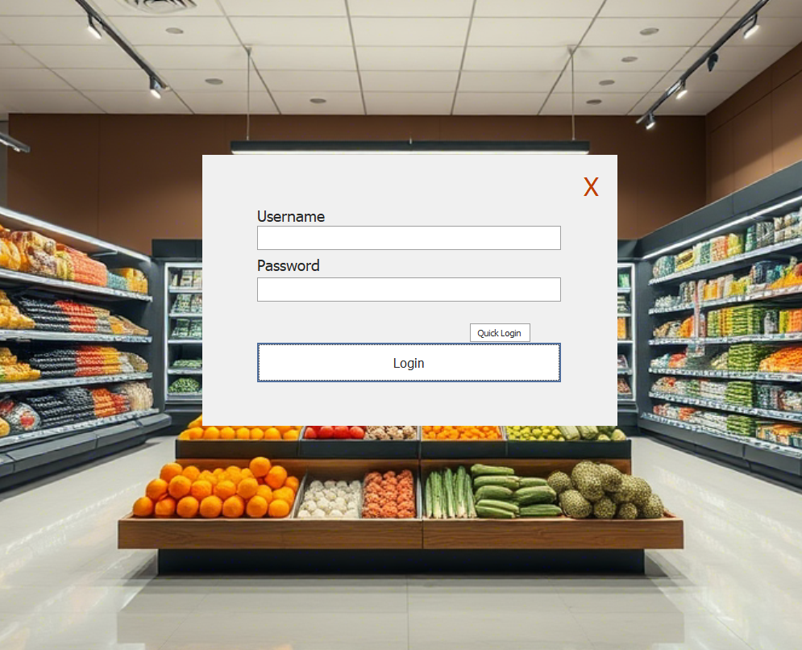  
- Dashboard: Navigation bar for POS, Inventory, Reports, Profile, Logout  
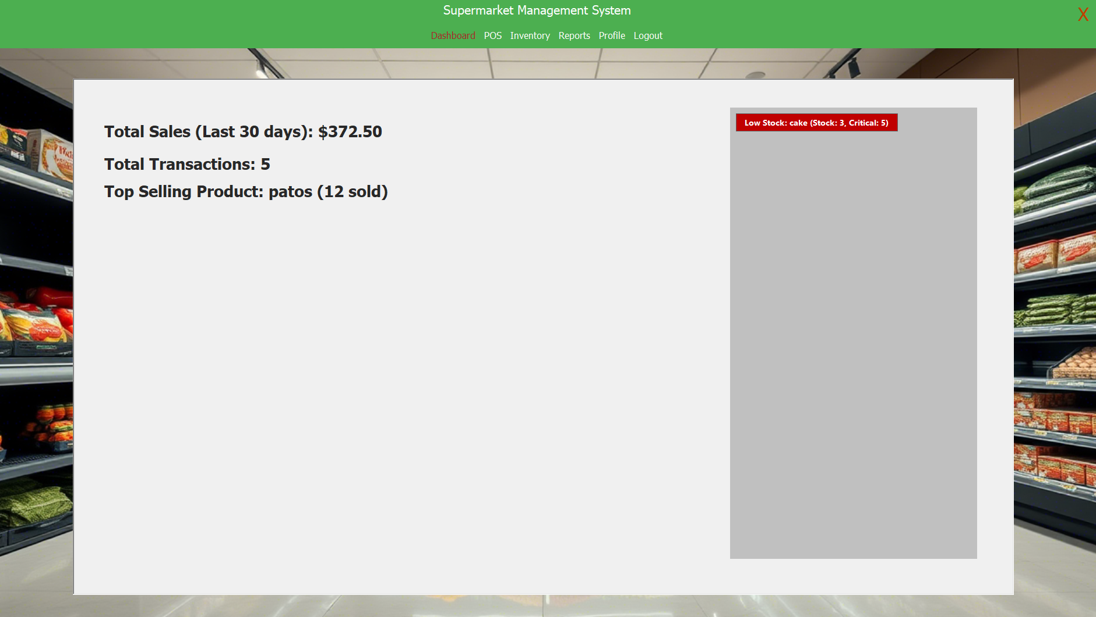

- Inventory Module: Table showing barcode, product name, price, quantity, and actions  
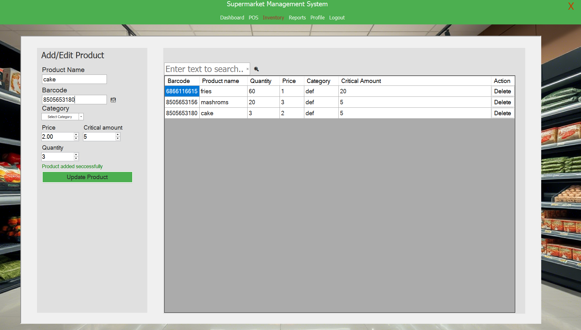  
- POS Page: Barcode input, dynamic cart, checkout, and print receipt  
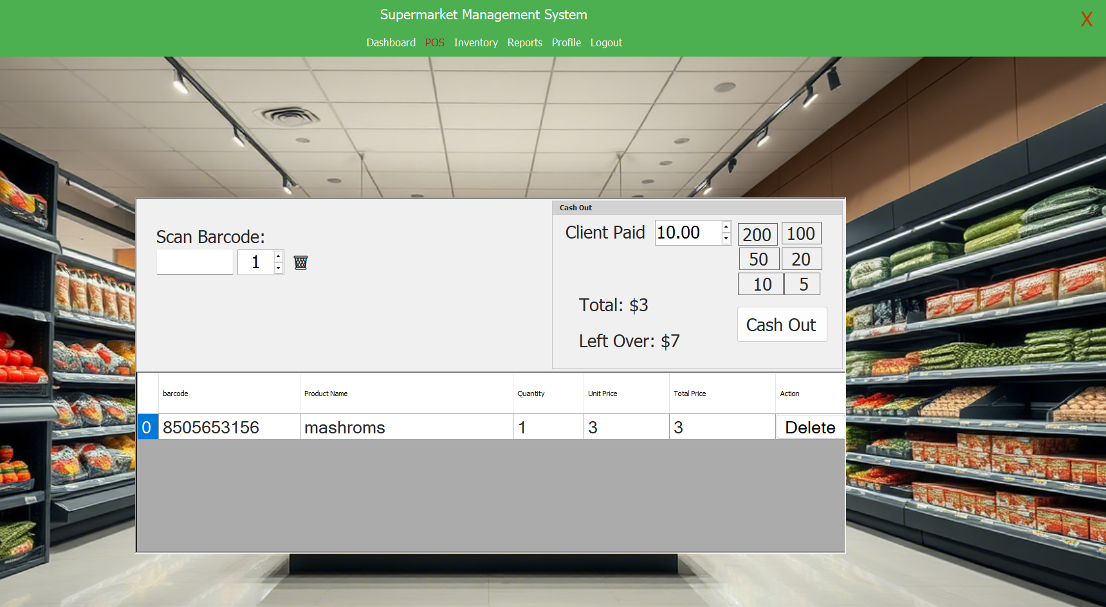  
- Reports Module: Date filters, table of sales, export to PDF  
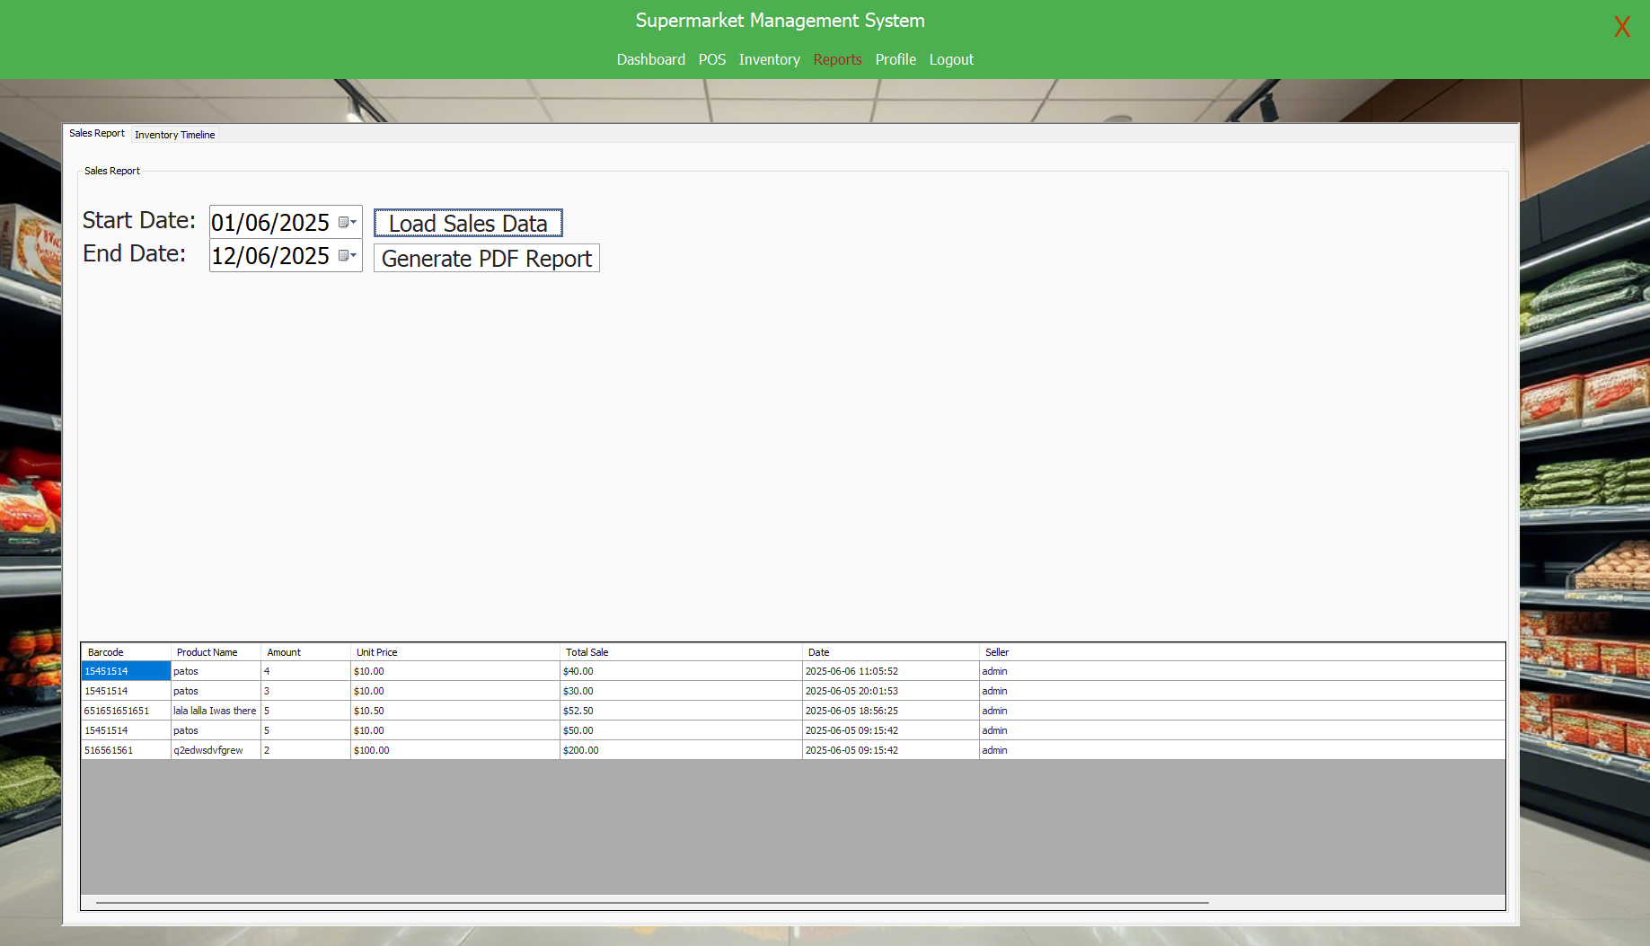

- Profile Page: Display and update user info  
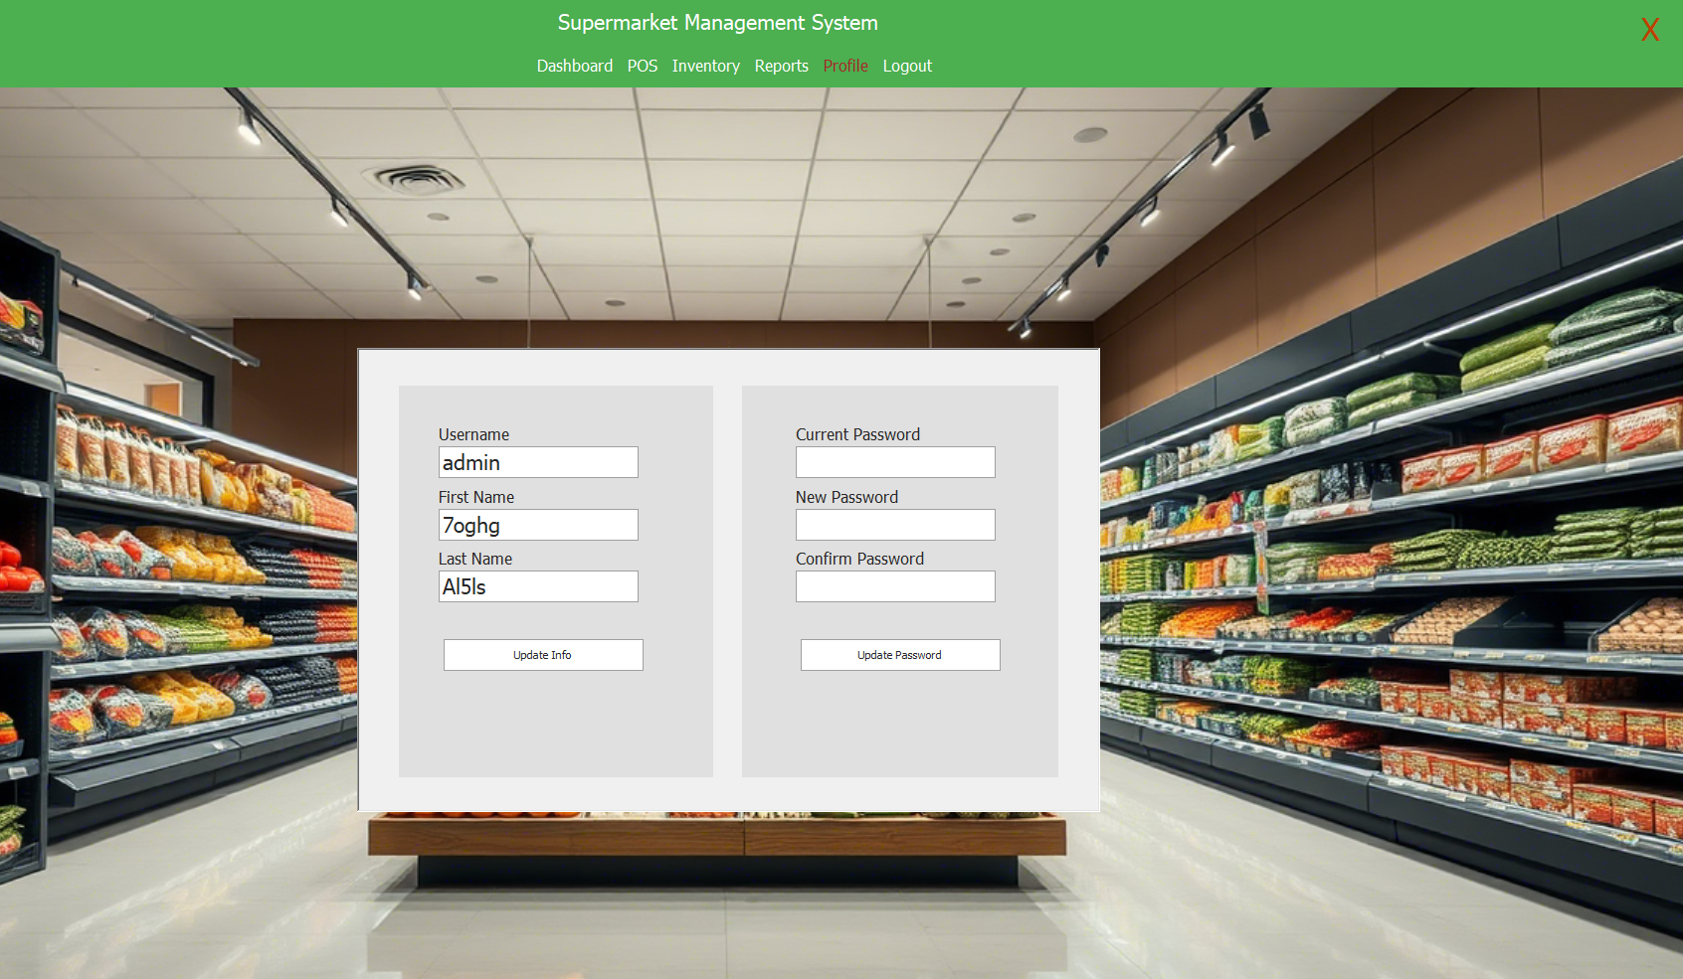

## 3.2 Hardware Interfaces

Standard PC with mouse and keyboard. Barcode scanner optional. Printer required for receipts.

## 3.3 Software Interfaces

.NET Runtime, SQLite3, DevExpress UI library, iTextSharp PDF toolkit.

## 3.4 Communications Interfaces

All functions are performed locally; no internet connection required.

# 4. System Features

## 4.1 Inventory Management

Allows users to manage product stock with CRUD operations. Each product has fields: barcode, name, category, quantity, price, and critical level.

## 4.2 Point of Sale (POS)

Sales interface allows users to scan products, add to cart, view totals, apply discounts, and print receipts.  
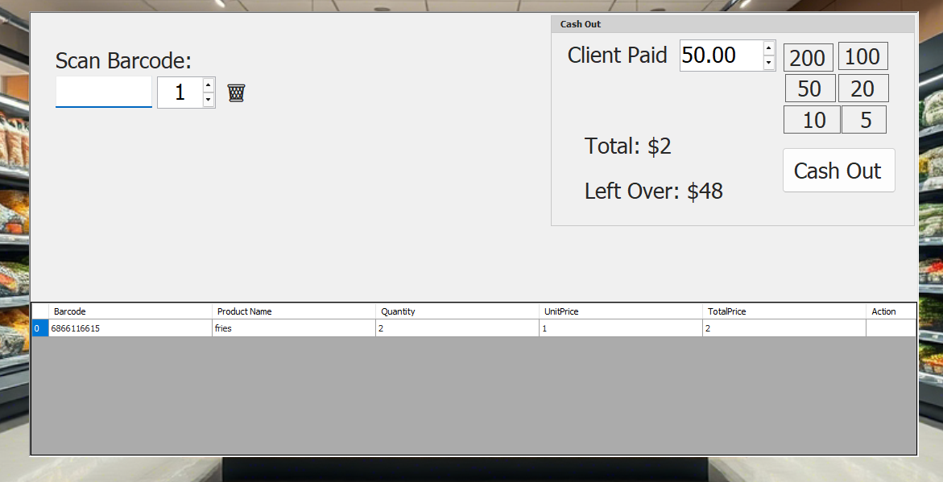

## 4.3 Reporting

Reports include sales by date and inventory change over time. Reports are exportable as PDFs and viewable in-app.  
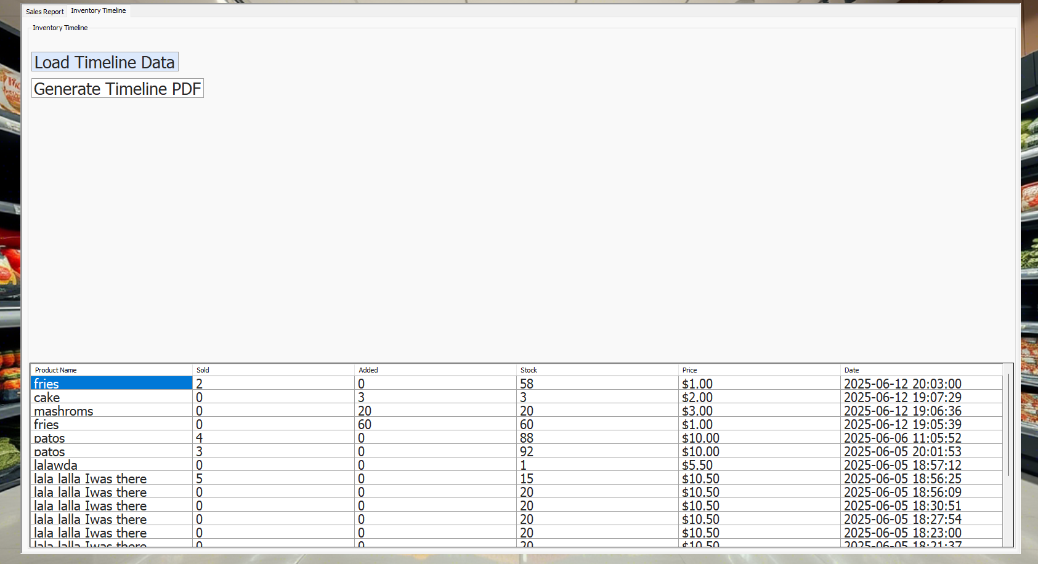

## 4.4 Profile Management

Users can update their names and passwords. Profile includes personal details and a summary of their actions.

# 5. Other Nonfunctional Requirements

## 5.1 Performance Requirements

Optimized to run on 2+ GHz processors with at least 2 GB RAM.

## 5.2 Usability

Simple layout with visual feedback. Icons and shortcuts included.

## 5.3 Security Requirements

Login protected by hashed passwords. Role-based access control enforced.

## 5.4 Software Quality Attributes

Modular structure, minimal crash reports, consistent interface elements.

## 5.5 Business Rules

Only Admins can delete users. Cashiers cannot edit products. Logs are immutable.

# 6. Appendix A: Glossary

- POS: Point of Sale, sales processing interface  
  
- SHA-256: Secure hash function used for password encryption  
  
- CRUD: Create, Read, Update, Delete  
  
- DevExpress: A library for advanced Windows Forms UI  
  
- iTextSharp: Library used to generate PDF reports  
  
- SKU: Stock Keeping Unit, unique identifier for inventory items  
  
- DB: Database